**DAY - 4**

**TASK 1:**

package com.DAY4;

import org.openqa.selenium.WebDriver;

import org.openqa.selenium.chrome.ChromeDriver;

import org.openqa.selenium.chrome.ChromeOptions;

import io.github.bonigarcia.wdm.WebDriverManager;

public class Task1

{

public static void main(String[]args)

{

WebDriverManager.chromedriver().setup();

ChromeOptions co=new ChromeOptions();

co.addArguments("--remote-allow-origins=*");

WebDriver driver=new ChromeDriver(co);

driver.get("https://www.google.com");

}

}

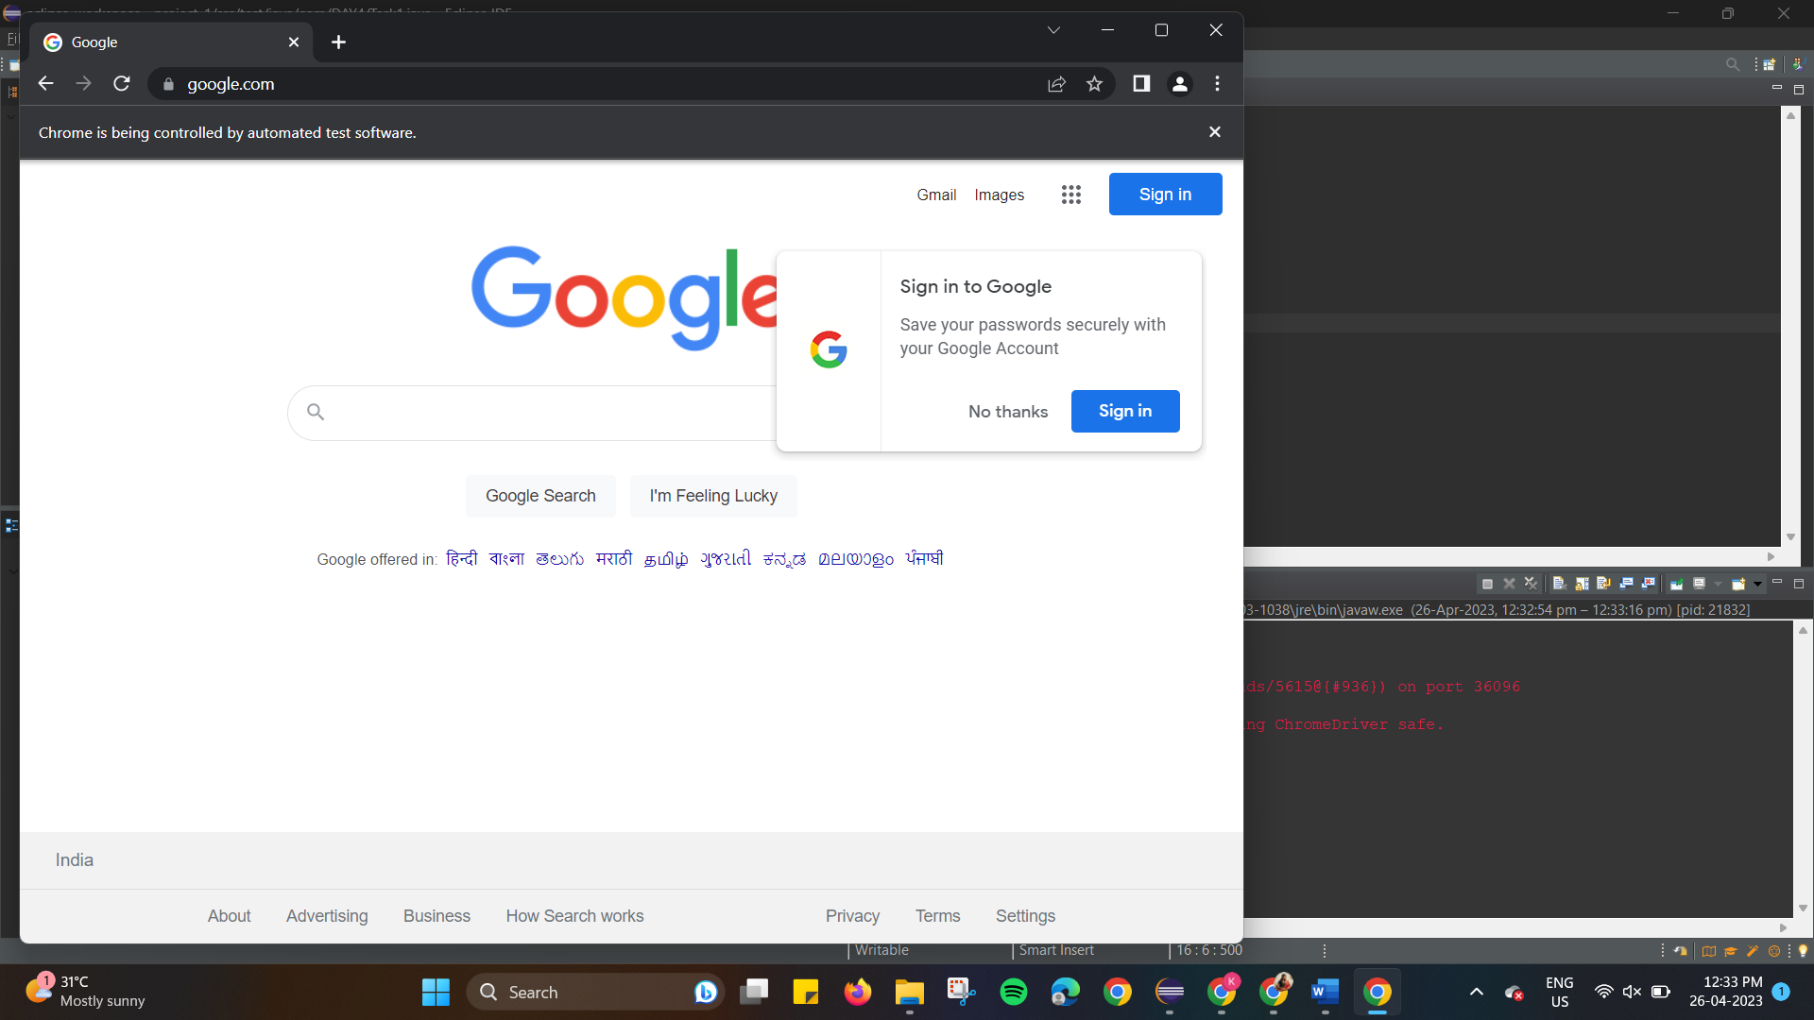

**TASK 2:**

package com.DAY4;

import org.openqa.selenium.By;

import org.openqa.selenium.JavascriptExecutor;

import org.openqa.selenium.WebDriver;

import org.openqa.selenium.WebElement;

import org.openqa.selenium.chrome.ChromeDriver;

import org.openqa.selenium.chrome.ChromeOptions;

import io.github.bonigarcia.wdm.WebDriverManager;

public class Task2

{

public static void main(String[]args)

{

WebDriverManager.chromedriver().setup();

ChromeOptions co=new ChromeOptions();

co.addArguments("--remote-allow-origins=*");

WebDriver driver=new ChromeDriver(co);

driver.get("https://demo.opencart.com/index.php?route=account/register&language=en-gb/");

WebElement fname = driver.findElement(By.id("input-firstname"));

fname.sendKeys("asAS");

WebElement lname = driver.findElement(By.id("input-lastname"));

lname.sendKeys("zxZX");

WebElement email = driver.findElement(By.id("input-email"));

email.sendKeys("aszx@gmail.com");

WebElement pwd = driver.findElement(By.id("input-password"));

pwd.sendKeys("1234");

JavascriptExecutor jsEx = (JavascriptExecutor)driver;

jsEx.executeScript("window.scrollBy(0,500)","");

WebElement noButton = driver.findElement(By.id("input-newsletter-no"));

noButton.click();

}

}

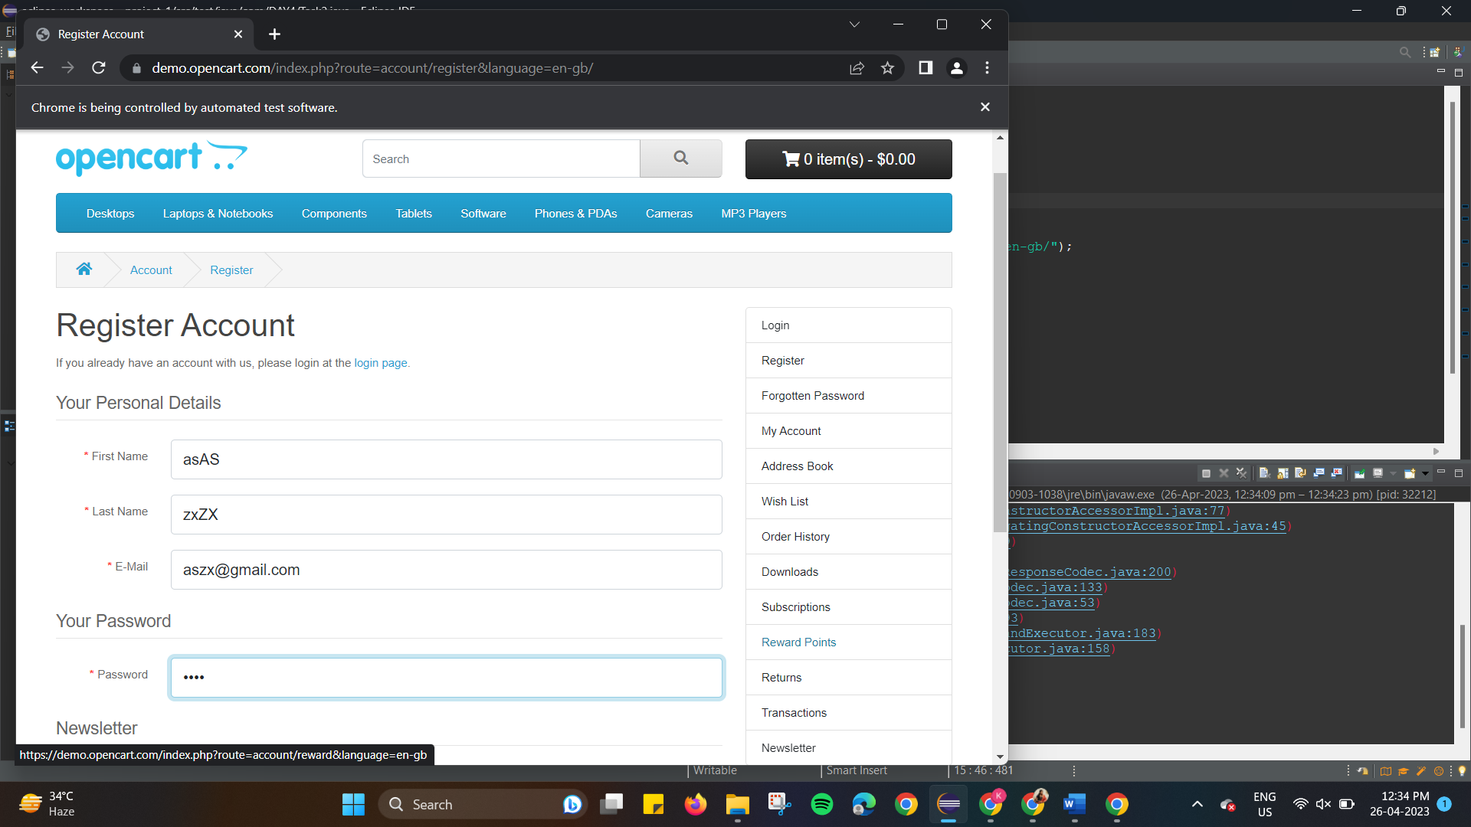

**TASK 3:**

package com.DAY4;

import org.openqa.selenium.By;

import org.openqa.selenium.JavascriptExecutor;

import org.openqa.selenium.WebDriver;

import org.openqa.selenium.WebElement;

import org.openqa.selenium.chrome.ChromeDriver;

import org.openqa.selenium.chrome.ChromeOptions;

import io.github.bonigarcia.wdm.WebDriverManager;

public class Task3 {

public static void main(String[] args) throws InterruptedException {

WebDriverManager.chromedriver().setup();

ChromeOptions co=new ChromeOptions();

co.addArguments("--remote-allow-origins=*");

WebDriver driver = new ChromeDriver(co);

driver.get("https://demo.opencart.com/index.php?route=checkout/voucher&language=en-gb");

WebElement fname = driver.findElement(By.xpath("//*[@id='input-to-name']"));

fname.sendKeys("Kaviya");

WebElement lname = driver.findElement(By.xpath("//*[@id='input-from-name']"));

lname.sendKeys("Venkat");

WebElement email = driver.findElement(By.xpath("//*[@id='input-to-email']"));

email.sendKeys("kaviya003@gmail.com");

WebElement e_mail = driver.findElement(By.xpath("//*[@id='input-from-email']"));

e_mail.sendKeys("venkat@gmail.com");

WebElement button = driver.findElement(By.xpath("//*[@id='input-to-name']"));

button.click();

JavascriptExecutor jsEx = (JavascriptExecutor)driver;

jsEx.executeScript("window.scrollBy(0,250)","");

Thread.sleep(3000);

WebElement message = driver.findElement(By.xpath("//*[@id='input-message']"));

message.sendKeys("Hello Everyone!!");

WebElement amount = driver.findElement(By.xpath("//*[@id='input-amount']"));

amount.sendKeys("1");

WebElement button1 = driver.findElement(By.xpath("//*[@id='form-voucher']/div[8]/div/div/input"));

button1.click();

}

}

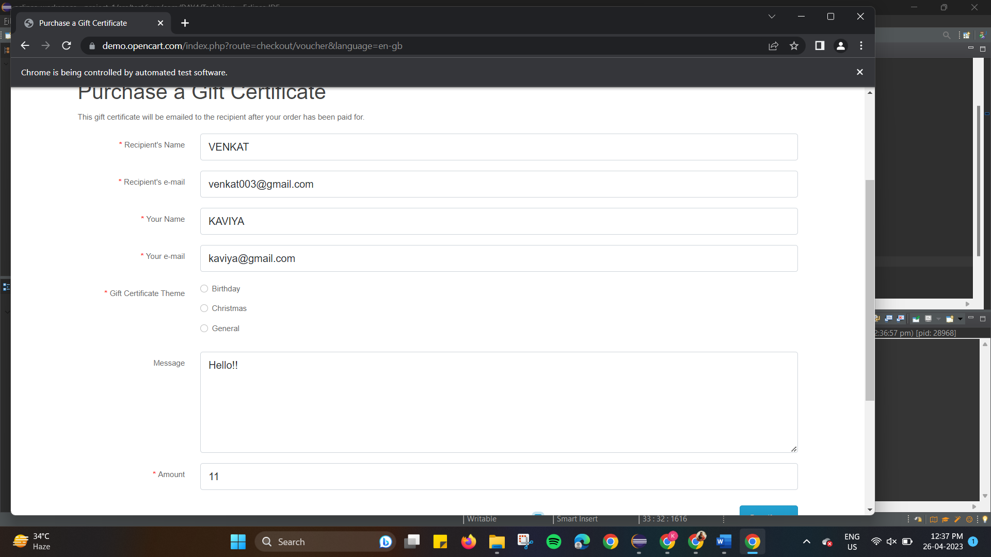

**TASK 4:**

package com.DAY4;

import org.openqa.selenium.By;

import org.openqa.selenium.WebDriver;

import org.openqa.selenium.WebElement;

import org.openqa.selenium.chrome.ChromeDriver;

import org.openqa.selenium.chrome.ChromeOptions;

import io.github.bonigarcia.wdm.WebDriverManager;

public class Task4 {

public static void main(String[] args) {

WebDriverManager.chromedriver().setup();

ChromeOptions co=new ChromeOptions();

co.addArguments("--remote-allow-origins=*");

WebDriver driver=new ChromeDriver(co);

driver.get("https://j2store.net/free/");

WebElement clothing=driver.findElement(By.xpath("//*[@id=\"Mod112\"]/div/div/ul/li[1]"));

clothing.click();

driver.manage().window().maximize();

driver.navigate().back();

driver.navigate().forward();

driver.navigate().refresh();

driver.close();

}

}

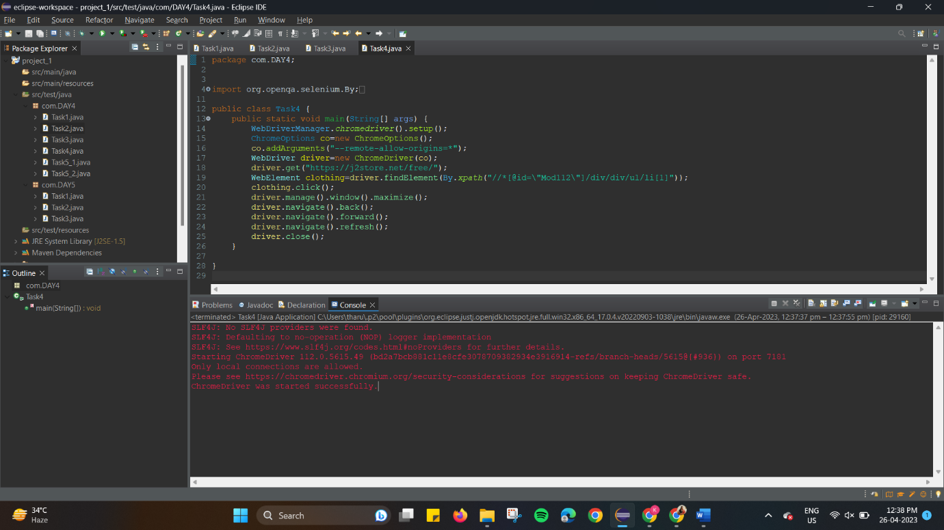

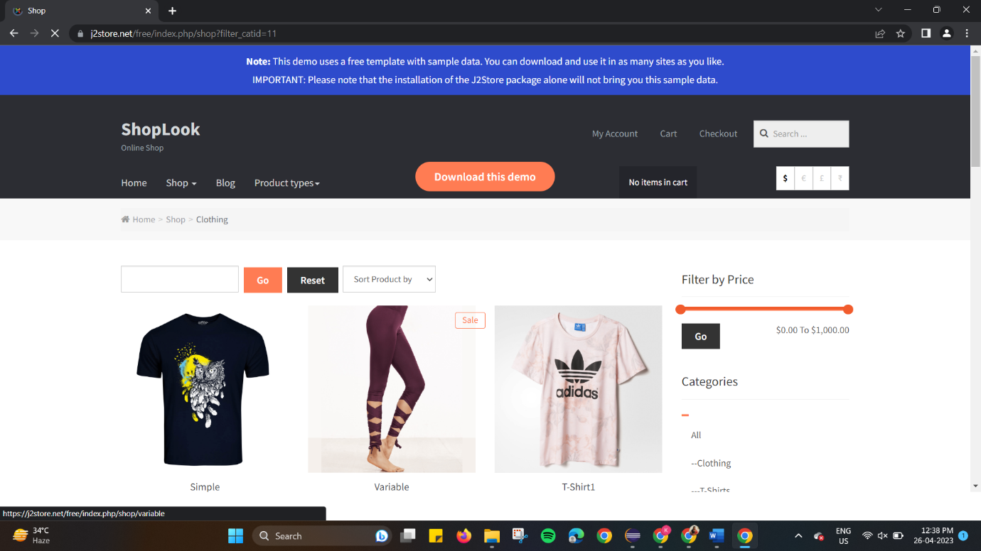

**TASK 5.1:**

package com.DAY4;

import org.openqa.selenium.By;

import org.openqa.selenium.WebDriver;

import org.openqa.selenium.WebElement;

import org.openqa.selenium.chrome.ChromeDriver;

import org.openqa.selenium.chrome.ChromeOptions;

import io.github.bonigarcia.wdm.WebDriverManager;

public class Task5_1 {

public static void main(String[] args) {

WebDriverManager.chromedriver().setup();

ChromeOptions co=new ChromeOptions();

co.addArguments("--remote-allow-origins=*");

WebDriver driver=new ChromeDriver(co);

driver.get("https://j2store.net/free/");

String url1=driver.getCurrentUrl();

if(url1.equals("https://j2store.net/free/"))

System.out.println("url validated");

WebElement clothing = driver.findElement(By.xpath("//*[@id=\"Mod112\"]/div/div/ul/li[1]/h4/a"));

clothing.click();

url1=driver.getCurrentUrl();

if(url1.equals("https://j2store.net/free/index.php/shop?filter_catid=11"))

System.out.println("url validated");

}

}

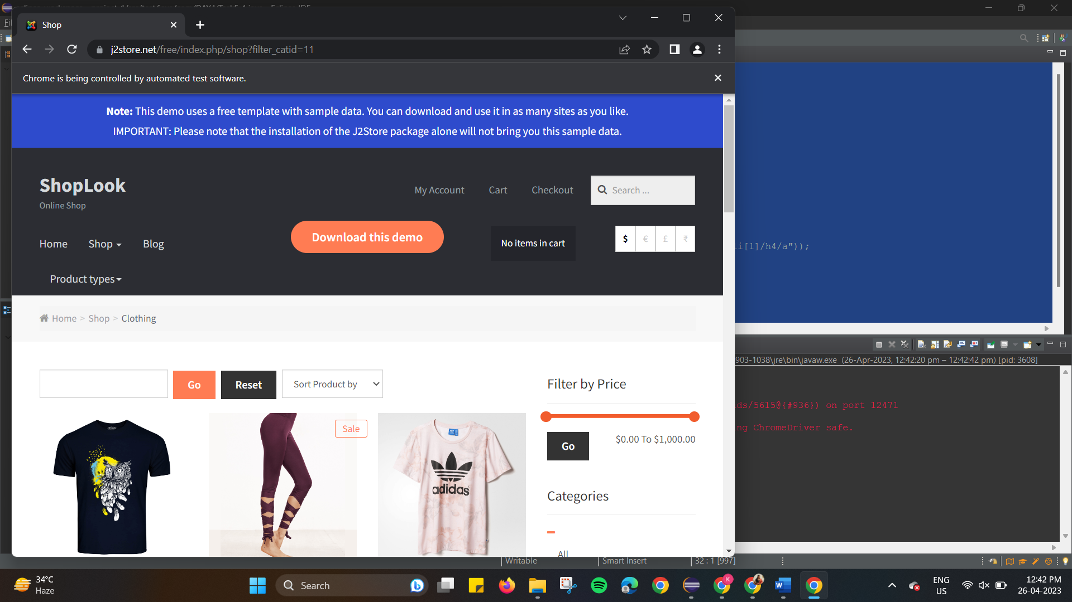

**TASK 5.2:**

package com.DAY4;

import java.util.List;

import org.openqa.selenium.By;

import org.openqa.selenium.JavascriptExecutor;

import org.openqa.selenium.WebDriver;

import org.openqa.selenium.WebElement;

import org.openqa.selenium.chrome.ChromeDriver;

import org.openqa.selenium.chrome.ChromeOptions;

import io.github.bonigarcia.wdm.WebDriverManager;

public class Task5_2{

public static void main(String[] args) throws InterruptedException {

WebDriverManager.*chromedriver*().setup();

//System.setProperty("webdriver.chrome.driver","C:\\drivers\\chromedriver.exe");

ChromeOptions co=new ChromeOptions();

co.addArguments("--remote-allow-origins=*");

WebDriver driver=new ChromeDriver(co);

driver.get("https://j2store.net/free/");

driver.manage().window().maximize();

JavascriptExecutor js=(JavascriptExecutor)driver;

js.executeScript("window.scrollBy(0,1000)", "");

driver.findElement(By.*linkText*("Clothing (5)")).click();

Thread.*sleep*(5000);

List<WebElement> l1=driver.findElements(By.*xpath*("//h2[@class='product-title']"));

for(WebElement link:l1){

System.out.println(link.getText());

}

}

}

